Session 4 - 1

import java.io.*;
import java.math.*;
import java.security.*;
import java.text.*;
import java.util.*;
import java.util.concurrent.*;
import java.util.function.*;
import java.util.regex.*;
import java.util.stream.*;
import static java.util.stream.Collectors.joining;
import static java.util.stream.Collectors.toList;
class Result {
public static int diagonalDifference(List<List<Integer>> arr) {
int primarySum = 0;
int secondarySum = 0;
int n = arr.size();
for (int i = 0; i < n; i++) {
primarySum += arr.get(i).get(i);

secondarySum += arr.get(i).get(n - 1 - i);
}
return Math.abs(primarySum - secondarySum);
}
}
public class Solution {
public static void main(String[] args) throws IOException {
BufferedReader bufferedReader = new BufferedReader(new InputStreamReader(System.in));
BufferedWriter bufferedWriter = new BufferedWriter(new FileWriter(System.getenv("OUTPUT_PATH")));
int n = Integer.parseInt(bufferedReader.readLine().trim());
List<List<Integer>> arr = new ArrayList<>();
IntStream.range(0, n).forEach(i -> {
try {
arr.add(
Stream.of(bufferedReader.readLine().replaceAll("\\s+$", "").split(" "))
.map(Integer::parseInt)
.collect(toList())
);
} catch (IOException ex) {
throw new RuntimeException(ex);
}
});
int result = Result.diagonalDifference(arr);
bufferedWriter.write(String.valueOf(result));
bufferedWriter.newLine();
bufferedReader.close();
bufferedWriter.close();
}
}

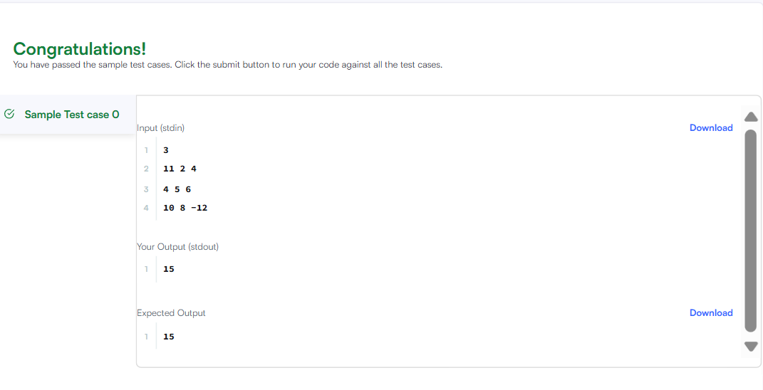

Session 4 -2
class Solution {
public int[][] transpose(int[][] matrix) {
int m = matrix.length;
int n = matrix[0].length;

int[][] result = new int[n][m];

for (int r = 0; r < m; r++) {
for (int c = 0; c < n; c++) {
result[c][r] = matrix[r][c];
}
}

return result;
}
}

